Amin Grundle

MYSQL ASSIGNMENTAmin

Contents

QUERY 1-10 (pgs 2-4)

EER DIAGRAM (pg 5)

PRIMARY/FOREIGN KEYS (pg 5)

ADDITIONAL QUERIES (pgs 6-8)

# QUERY 1

SELECT whole script.

## QUERY 2

SELECT first names in ascending order.

### QUERY 3

SELECT customer birthdate greater than 1990, 01, 01

#### QUERY 4

SELECT first names beginning with M and last names beginning with A

##### QUERY 5

SELECT points, first name and last name

###### QUERY 6

Min and Max points

QUERY 7

Levy Mynett City

QUERY 8

Unit prices BETWEEN 3 AND 8

QUERY 9

Order status of ‘Order 10’

QUERY 10

Shipper name of shipper_id (5)

**EER DIAGRAM**

PRIMARY KEYS:

order_items : none

products: product_id

shippers: shipper_id

order_statuses: order_status_id

orders: order_id

customers: customer_id

FOREIGN KEYS

order_items : order_id, product_id

products:

shippers:

order_statuses:

orders: customer_id, statuses, shipper_id

customers:

#### **ADDITIONAL QUERIES**

**Counting the number of customers per city.**

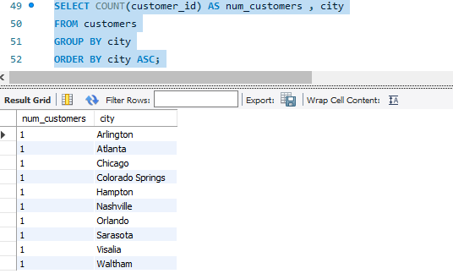

**Looking for customers with points above or equal to '2000'.**

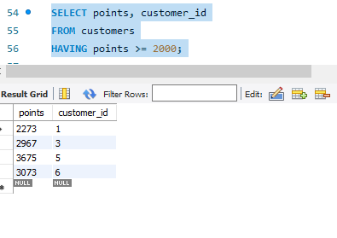

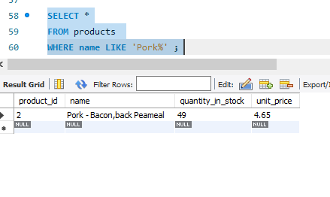

**Searching for specific product info by name.**

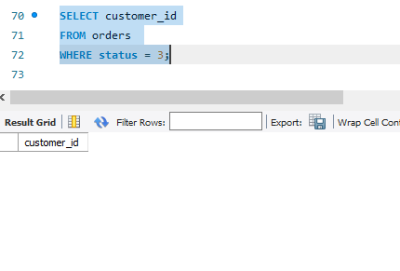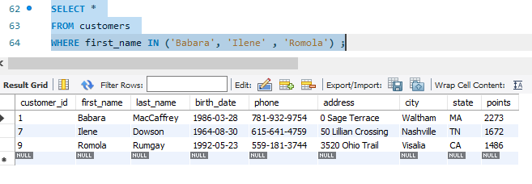**Looking for specific customer info.**

**Searching for customer order statuses.**

**Checking to see which orders have been shipped, excluding those that haven't.** 